CONTROL SYSTEMS DESIGN WITH QUEUES
Control Systems Design with Queues Report
Project: Darvycom Brisbane Engineering Laboratory Network and DSP Upgrade
Unit: ICTTEN827
Location: Blocks A and B, Brisbane Engineering Laboratory
Project Manager: Leonardo Matias Ciarcia
Document ID: C6-QUEUE-CONTROL-02
Version: 1.1
Date: 16 March 2026
- Executive summary

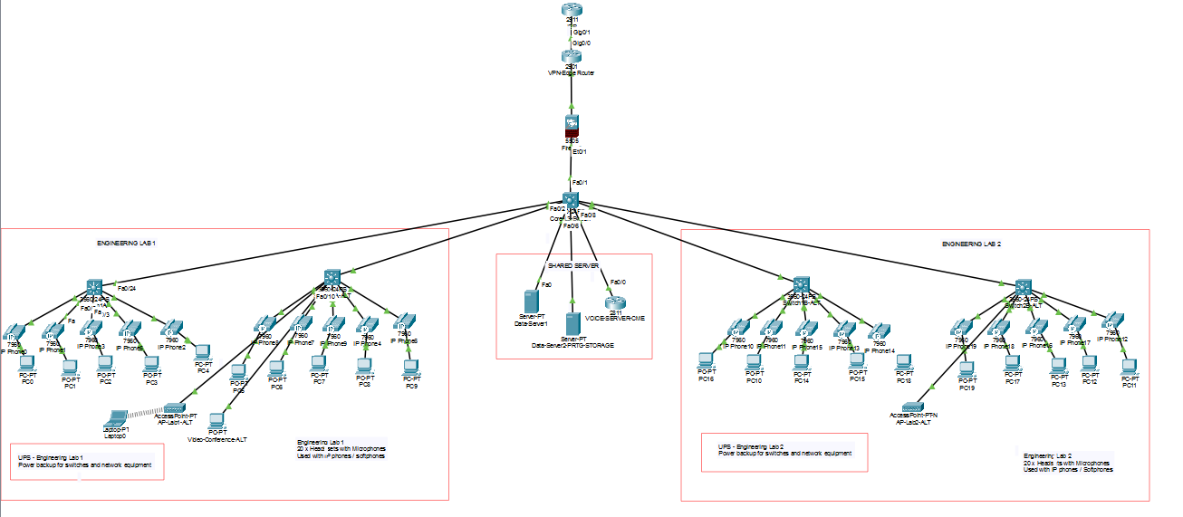
This report presents a queue-based control system for the Darvycom Network output interface. The model receives voice, video and general data packets, classifies them into three logical queues and adjusts control actions according to queue occupancy, delay, utilisation and packet drops.
The design uses priority service for voice, weighted service for video and controlled remaining capacity for general data. Four controller states are used: GREEN, AMBER, RED and RECOVERY.
The purpose of the simulation is to evaluate congestion behaviour before QoS settings are implemented on the operational network.

2. Control-system objectives
The control system must:
- protect VoIP and video traffic;
- identify increasing congestion;
- defer non-critical traffic during busy periods;
- rate-limit normal data during overload;
- prevent uncontrolled queue growth;
- record packet delay and drops;
- recover gradually after congestion;
- avoid starvation of lower-priority traffic;
- provide information that can be monitored and reported.

3. System boundary and assumptions
Element | Model value
Input traffic | Voice, video and normal data
Output server | One monitored network interface
Test capacity | 100 Mbit/s
Production uplinks | Gigabit Ethernet
Average analytical packet size | 1,500 bytes
Queue capacity | 1,000 packets
Controller sample period | 1 second
Simulation processing | Packet-based or small time-step
Main outputs | Occupancy, delay, utilisation, drops and state history
The 100 Mbit/s link is used for the simulation because congestion can be demonstrated more clearly than on the production Gigabit uplink.

4. Queue architecture
Queue | Traffic class | Service method | Objective
Q1 | VoIP signalling and RTP | Strict priority with policing | Lowest delay and loss
Q2 | Video conferencing | Weighted service after Q1 | Stable video delivery
Q3 | General data and backups | Remaining weighted capacity | Protect real-time services
Strict priority is not unlimited. A policing or service-budget rule is required so that Q1 cannot permanently prevent Q2 and Q3 from receiving service.

5. Queue equations
Service rate:
μ = C / (L × 8)
For C = 100,000,000 bit/s and L = 1,500 bytes:
μ = 8,333.33 packets/s
Queue utilisation:
ρ = λ / μ
Queue change:
dq/dt = λ − μ
Stable condition:
λ < μ
Unstable condition:
λ ≥ μ
For the overload test:
λ = 9,000 packets/s
μ = 8,333 packets/s
ρ = 1.08
Because ρ is greater than 1, the queue grows unless the controller applies packet dropping, shaping or rate limiting.

6. Controller states
State | Occupancy | Controller action | Exit condition
GREEN | Below 50% | Normal scheduling and monitoring | Occupancy reaches 50%
AMBER | 50%–75% | Increase real-time protection, warn operator and defer backups | Below 45% or reaches 75%
RED | Above 75% | Rate-limit Q3, apply early data drops and preserve Q1/Q2 | Below 65% for five samples
RECOVERY | Falling after RED | Gradually restore Q3 and check stability | Below 45% for five samples
Different entry and exit thresholds provide hysteresis. This reduces rapid switching when queue occupancy remains near one threshold.

7. Control logic
- Generate voice, video and data packet-arrival events.
- Classify each packet into Q1, Q2 or Q3.
- Check available queue capacity.
- If capacity is available, enqueue the packet.
- If capacity is exceeded, record a class-specific packet drop.
- When the output link becomes available, service Q1 within its configured budget.
- Service Q2 using its assigned weight.
- Allocate the remaining service capacity to Q3.
- Calculate waiting time and queue delay.
- Every second, calculate occupancy, utilisation, drops and delay.
- Select the correct controller state.
- Record state changes and control actions.
- Export the graphs and final scenario table.

8. MATLAB-style pseudocode
Initialise event list, Q1, Q2 and Q3
Set controller state to GREEN

While simulation time is less than duration:

Remove the next event

If event is ARRIVAL:
Classify packet
Add packet to Q1, Q2 or Q3
Record a drop if capacity is exceeded

If event is DEPARTURE:
Select next packet using priority and weights
Record waiting time
Transmit next packet

If event is SAMPLE:
Calculate occupancy
Calculate delay and utilisation
Calculate drops
Apply controller-state rules
Record the state and action

End simulation

Export queue length, delay, drops, utilisation and state history

9. Test scenarios
Scenario | Arrival rate | ρ | Expected behaviour | Controller state
S1 – Normal | 5,000 pkt/s | 0.60 | Low and stable queue | GREEN
S2 – Busy | 7,500 pkt/s | 0.90 | Delay becomes sensitive to traffic variation | GREEN/AMBER
S3 – Overload | 9,000 pkt/s | 1.08 | Queue reaches capacity without control | RED
S4 – Recovery | 4,000 pkt/s | 0.48 | Backlog drains | RECOVERY then GREEN

10. Representative calculated outputs
Metric | S1 | S2 | S3 | S4
Arrival rate | 5,000 | 7,500 | 9,000 | 4,000 pkt/s
Service rate | 8,333 | 8,333 | 8,333 | 8,333 pkt/s
Utilisation | 60% | 90% | 108% | 48%
Average M/M/1 time | 0.30 ms | 1.20 ms | Unstable | 0.231 ms
Packet drops | None expected | Possible during bursts | Required when full | None expected
Main action | Monitor | Warn/defer backup | Limit Q3/protect Q1/Q2 | Restore gradually
These figures are analytical outputs. The final evidence must include screenshots of the executed simulation to verify the calculated behaviour.

11. Queue overflow and recovery
During S3:
Queue growth = 9,000 − 8,333
Queue growth = 667 packets/s
Starting from an empty queue:
Time to reach 50% occupancy = 500 / 667
Time = approximately 0.75 seconds
Time to reach 75% occupancy = 750 / 667
Time = approximately 1.12 seconds
Time to reach full capacity = 1,000 / 667
Time = approximately 1.50 seconds
During S4:
Drain rate = 8,333 − 4,000
Drain rate = 4,333 packets/s
Time to drain 1,000 packets:
Time = 1,000 / 4,333
Time = approximately 0.231 seconds
The controller remains in RECOVERY for the configured stability period even if the mathematical queue drains quickly.

12. Control actions by traffic class

Voice
- maintain the highest scheduling priority;
- preserve low delay and jitter;
- police excessive voice traffic;
- alarm if voice performance exceeds its target.

Video
- allocate a guaranteed weighted share;
- reduce normal data before reducing video;
- monitor delay, jitter and packet loss;
- preserve sufficient throughput for conferencing.

General data
- use available capacity after voice and video requirements;
- defer backups during AMBER;
- rate-limit large transfers during RED;
- restore bandwidth gradually during RECOVERY.

13. Acceptance criteria
Criterion | Pass condition
Voice protection | Q1 has the lowest measured waiting time
Controlled overload | Queue remains bounded or documented drops occur
Recovery | Controller returns to GREEN after the stability period
Fairness | Q2 and Q3 continue receiving service
Observability | Every state change is timestamped
Monitoring | Delay, drops, occupancy and utilisation are exported
Stability | Controller does not repeatedly oscillate between states

14. Risks and limitations
Risk or limitation | Treatment
Real packets have different sizes | Use traffic-specific distributions in an extended model
Arrivals are not perfectly exponential | Test burst and deterministic scenarios
Strict priority may cause starvation | Apply policing and minimum service weights
Thresholds may cause rapid switching | Use hysteresis and five-sample recovery checks
Home monitoring is not production data | Label PRTG evidence as representative
Packet Tracer has simulation limitations | Compare with calculations and documented assumptions

15. Conclusion
The queue-based control system provides a repeatable method for evaluating QoS and congestion control before Network solution is placed into operation. The design protects voice and video, controls general data during overload, records measurable outputs and restores capacity gradually after congestion.

